#### Citizen_RC - Voter ID Purpose

* Provide Facility to view current owner & occupier details in grid View.
* Provide a facility to add new residents and attach the documents.
* Type of document & relation should be picked from the master.

Type of documents

Ration card

Marriage certificate

Affidavit of Owner

Owner concern

Birth certificate

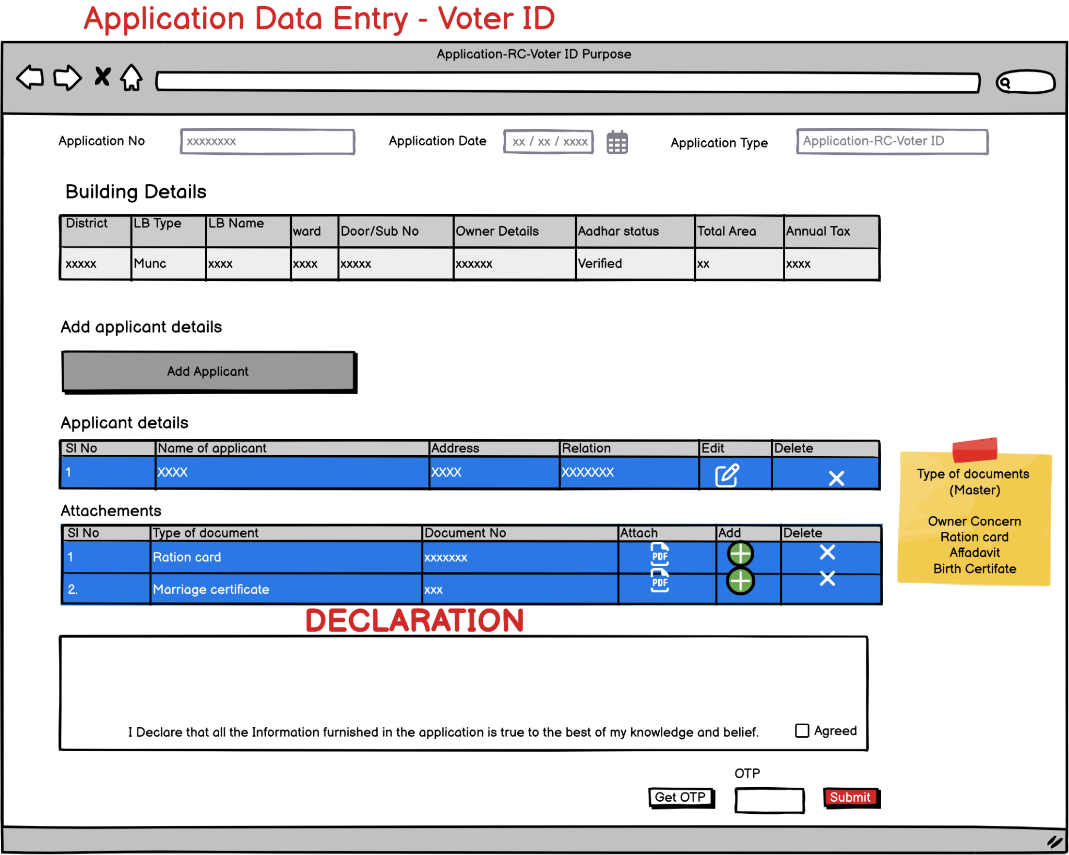

8151 0739 1426

8921709275

8921709275

670102

Thalassery,Kannur(dist)

Sowparnika

s/o Mukundan.k

Abhilash.k